Activity Sheet Answers
Chapter 3, Lesson 3
Density of Water

DEMONSTRATION
- Imagine lifting a small and a large amount of water. The larger amount of water would have the most mass.

You know how to find the density of solids. Do you think a liquid, like water, can have a density?
Yes, liquids have density. If the liquid has mass and takes up volume, then it must have density according to D=m/v.
How do you think you could find the density of a liquid like water?
You can find the density of water by dividing the mass of a sample of water by the volume of the sample.

Could both the small and large amounts of water have the same density? Explain.
Yes, they should. Although the larger amount of water is heavier, it also has more volume. The smaller amount of water is lighter, but has less volume. Without doing any math, the relationship between mass and volume could be the same for both samples so they would work out to the same density.

ACTIVITY

- Look at your values for density in your chart. Does the density of the different volumes of water seem to be about the same?
Yes, the density is about 1g/cm³ in all cases.

- What do you think is the density of water in g/cm³?
The density of water is 1g/cm³.

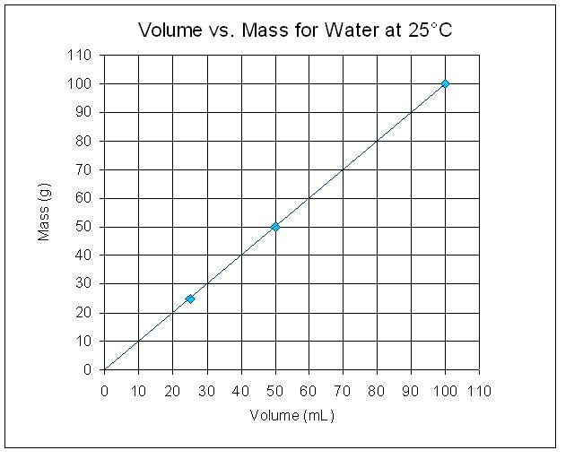
- Using the data from your chart, graph the volume and mass for 100 mL, 50 mL, and 25 mL.
The density of water should be 1g/cm³ for all samples, as indicated by a linear relationship between Mass and Volume.

- Look at the graph you made.
If you measured 40 milliliters of water, what do you think its mass would be? What would its density be?
The mass would be 40g. The density would be 1g/cm³.

- Choose any volume of water between 1 and 100 milliliters. Based on the graph, what would its mass be? What would its density be?
Answers will vary, but the volume and mass should be equal to one another, which would make the density calculate to 1g/cm³.

- Density is a “characteristic property” of a substance. This means that the substance will have the same density no matter how big or small the sample is. Would you say that density is a characteristic property of water? Why or why not?
Yes, density is a characteristic property of water because in all of our measurements, we confirmed that the density is 1g/cm³ no matter how large or small the sample size.

EXPLAIN IT WITH ATOMS & MOLECULES

- Sample B is half the volume of Sample A.
Do the samples have the same mass? Do the samples have the same density?
No, the samples will not have the same mass because they contain different numbers of water molecules. The samples do, however, have the same density because the difference in mass is balanced by the difference in volume.

TAKE IT FURTHER

- The density of a liquid is the same no matter the size of the sample. Could this be true for solids, too? Calculate the density of each of the three samples to find out.
Yes, solids have the same density no matter how large or small the sample size.
Sample A has a mass of 200 g. What is the density of Sample A?
Density_{A}= m_{A}/v_{A} = 200g/100cm³ = 2g/cm³
If you cut Sample A in half and looked at only one half you would have Sample B. What is the density of Sample B?
Density_{B}= m_{B}/v_{B} = 100g/50cm³ = 2g/cm³
If you cut Sample B in half you would have Sample C. What is the density of Sample C?
Density_{C}= m_{C}/v_{C} = 50g/25cm³ = 2g/cm³

